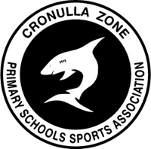

Code of Conduct

Cronulla Primary Schools Sports Association (PSSA) Codes of Conduct are to be signed by all students, teachers and parents/caregivers who participate in any Zone PSSA activities including carnivals, team sports and representative trials.
Cronulla PSSA officials and coaches are school teachers, not professional coaches, who do their best to ensure that all children are given the chance to participate and reach their full potential in a safe and fair sporting environment.

The values of Cronulla PSSA sport are

Teamwork

Fair Play

Excellence

Enjoyment

Respect

All students, schools, coaches, parents and spectators are expected to abide by the advertised codes of conduct to ensure all participants achieve their best.
Zone personnel are to ensure everyone involved in PSSA events including students, teachers, officials, parents/spectators, understand their responsibilities regarding fair play and the Cronulla Zone PSSA codes of conduct.

CONSEQUENCES RE BREAKING : CODES OF CONDUCT
Students:
Should a student break the code of conduct that they have signed they must be prepared to accept both the responsibility for and the consequences resulting from their actions at sport. These include:
- Possibly missing scheduled events;
- Being sent off and replaced for the remainder of a game
- Possible suspension from future Zone sporting events;
- Accepting consequences in line with the Cronulla Zone PSSA code of conduct and the Department of Education’s code of conduct.
Parents/Spectators:
Should parents/spectators break the signed code of conduct they need to be prepared to accept both the responsibility for and the consequences resulting from their actions at a Cronulla Zone PSSA sporting event. These include:
- Being asked to leave the premises or ground/park by a Zone teacher/Convener;
- Meeting with their school principal to discuss future attendance at Cronulla Zone PSSA sporting events;
- Police being called and parents/spectators being charged with section 60E where Zone teachers feel that student or teacher safety is threatened or intimidated by either verbal or physical abuse.
Teachers/Officials:
- Any reported incidents of unfair play or inappropriate behaviour as a teacher/official at a Cronulla PSSA Zone event will be dealt with in line with the NSW DoE’s Teacher Code of Conduct under the direction of the teacher’s school principal and Zone Executive.
- Teachers/officials are to avoid any hint of criticising the officiating of a match/carnival, particularly in front of students or parents/spectators. Report any problems to the relevant Cronulla PSSA Zone Convener as soon as possible, who will inform the Zone Executive if so warranted.

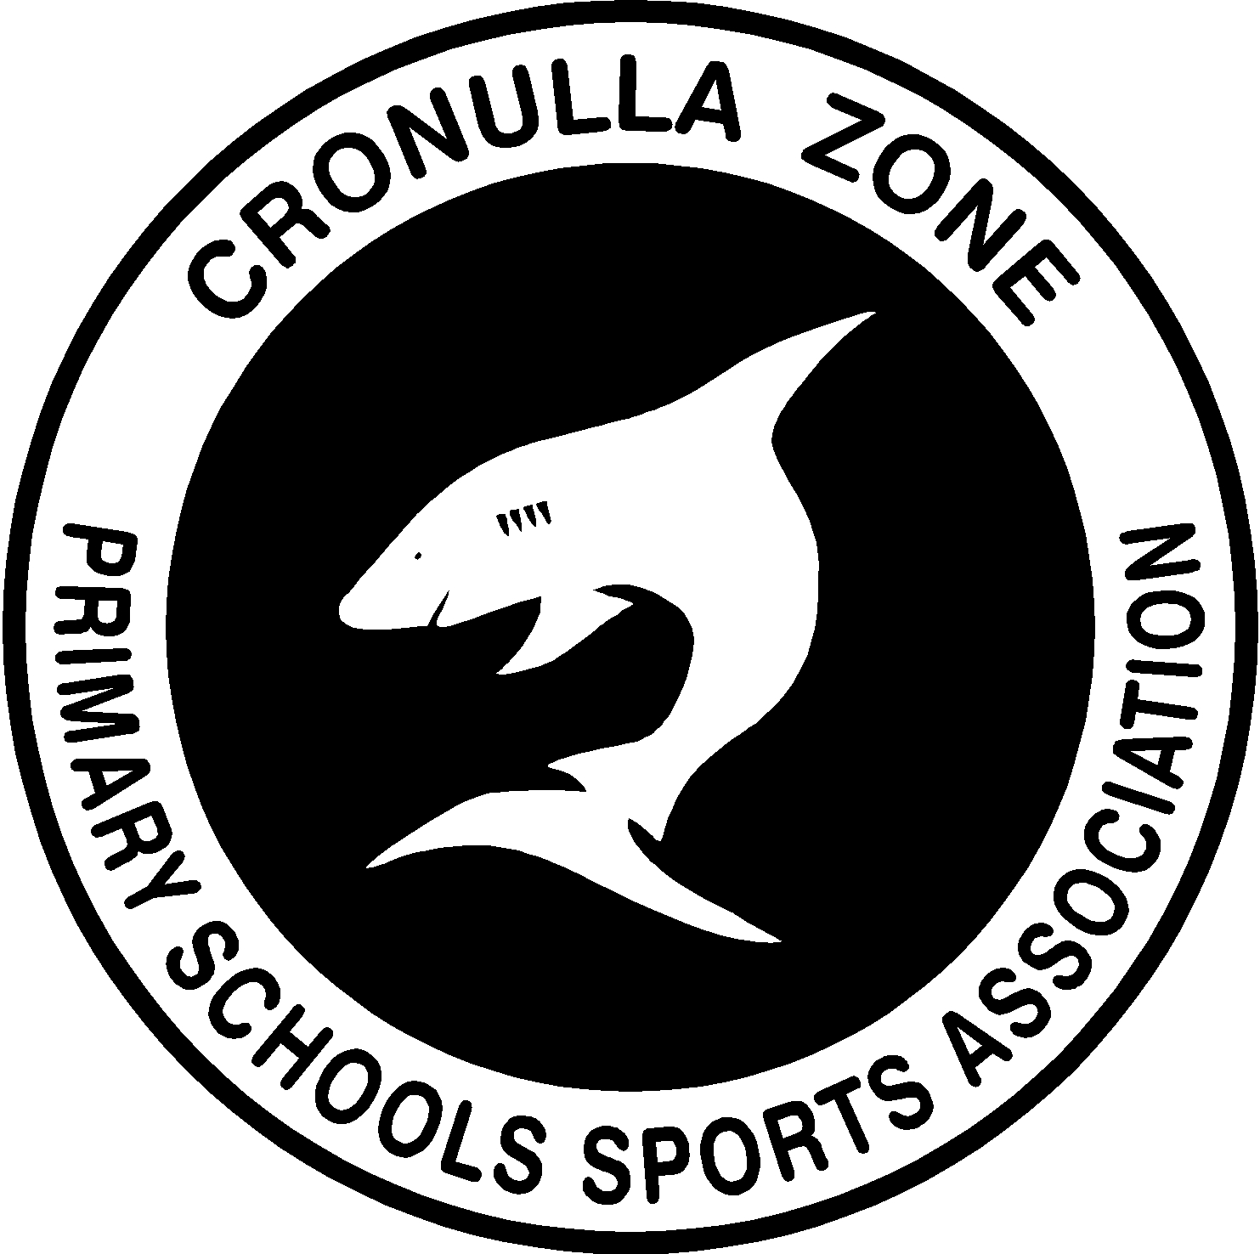
CRONULLA ZONE PSSA

Teachers and Coaches Code of Conduct

- Set a good example for your players.

- Encourage and create opportunities to develop individual skills.

- Teach a wide range of team skills.

- Ensure that the sport is appropriate for the age group and skill levels of the players involved.

- Teach your players to be friendly towards officials and opponents.

- Give all interested students a chance to participate in training and in games.

- Remove from the field of play any of your players whose behaviour is not acceptable.

- Keep your own knowledge of coaching and development of the game up to date.

I will ensure I will conduct my PSSA role in accordance with the guidelines set out for my specific sport DoE document entitled “Guidelines for the Safe Conduct of Sport and Physical Activity in Schools”.

CRONULLA ZONE PSSA

Values: Teamwork, Fair Play, Excellence, Enjoyment, Respect

Players’ Code of Conduct Contract

Player’s Code
- Play for the fun of it.
- Work equally hard for yourself and your team.
- Be a good sport and encourage your fellow team members.
- Cooperate at all times with your coach, team mates and opponents.
- Compete by the rules and always abide by referees/umpires or touch judge decisions.
- Control your temper and behaviour whilst on and off the playing field and make no criticism either by word or gesture.
- Whilst on the sidelines do not touch any sporting equipment. Sit and support your participating school mates.
- Be modest in success and generous in defeat (i.e. don’t show off when successful or be a bad sport when defeated).

I have read and agree to abide by the above “Players’ Code of Conduct” when competing in the ……………………………………….. Public School PSSA …………………………….………… Team.

I understand that if I break the Code the privilege of representing my school may be taken away from me.

Team Members
______________________
______________________
______________________
______________________
______________________
______________________
______________________
______________________
______________________
______________________
______________________
______________________
______________________
______________________
______________________
Signature
______________________
______________________
______________________
______________________
______________________
______________________
______________________
______________________
______________________
______________________
______________________
______________________
______________________
______________________
______________________
Date
______________________
______________________
______________________
______________________
______________________
______________________
______________________
______________________
______________________
______________________
______________________
______________________
______________________
______________________
_____________________
CRONULLA ZONE PSSA

Values: Teamwork, Fair Play, Excellence, Enjoyment, Respect

Parents’/Spectators’ Code of Conduct Contract

Parents’/Spectators’ Code

- Remember that children play sport for their enjoyment, not yours.
- Encourage children to participate, do not force them.
- Focus on the child’s efforts and performance rather than winning or losing.
- Encourage children to always participate according to the rules and the officials’ decisions.
- Never ridicule or yell at a child for making a mistake or losing a game. Positive comments are motivational.
- Applaud good performance and efforts from each team and congratulate all participants upon their performance regardless of the game’s outcome.
- Show respect for your child’s opponents for without them there would be no game.
- Show appreciation of volunteer coaches, officials and administrators for without them, your child could not participate.
- Do not publicly question the officials’ judgement and never their honesty.
- If you disagree with an official raise the issue through the appropriate channels in writing rather than questioning the official’s judgement and honesty in public.

I, ……………………………….…………………, have read and agree to abide by the following
Parent’s/Caregiver’s name

“Parents’/Spectators’ Code of Behaviour” when attending PSSA sporting events.

I understand that if I break the Code I may not be able to be a spectator of this competition as a

consequence of my actions.

Signed: …………………………………..…..…. Date: …………………
Parent’s/Caregiver’s signature

CRONULLA ZONE PSSA

Values: Teamwork, Fair Play, Excellence, Enjoyment, Respect

Players’ Code

Rationale:
Representing the school in PSSA Competitions provides an opportunity for talented athletes to extend their skills and compete against similarly skilled students from other schools. Representing the school is an honour and students have a responsibility to compete at all times in a manner that brings credit to themselves and their school. The following Code of Conduct has been devised to guide the achievement of this outcome.

- Play for the fun of it.
- Work equally hard for yourself and your team.
- Be a good sport and encourage your fellow team members.
- Cooperate at all times with your coach, team mates and opponents.
- Compete by the rules and always abide by referees/umpires or touch judge decisions.
- Control your temper and behaviour whilst on and off the playing field and make no criticism either by work or gesture.
- Whilst on the sidelines do not touch any sporting equipment. Sit and support your participating school mates.
- Be modest in success and generous in defeat (i.e. don’t show off when successful or be a bad sport when defeated).

Parents’/Spectators’ Code

Rationale:
The support of parents and spectators at PSSA events is a welcomed and highly valued contributor to students overall enjoyment of their involvement in school sport. The following Code of Conduct has been devised to ensure that high levels of student enjoyment are maintained.

- Remember that children play sport for their enjoyment, not yours.
- Encourage children to participate, do not force them.
- Focus on the child’s efforts and performance rather than winning or losing.
- Encourage children to always participate according to the rules and the officials’ decisions.
- Never ridicule or yell at a child for making a mistake or losing a game. Positive comments are motivational.
- Applaud good performance and efforts from each team and congratulate all participants upon their performance regardless of the game’s outcome.
- Show respect for your child’s opponents for without them there would be no game.
- Show appreciation of volunteer coaches, officials and administrators for without them, your child could not participate.
- Do not publicly question the officials’ judgement and never their honesty.
- If you disagree with an official raise the issue through the appropriate channels in writing rather than questioning the official’s judgement and honesty in public.

